*Directions:  Show all work, and answer each question that is asked.  Explanations should be given in complete sentences.  All graphs should be drawn accurately on this sheet, and be fully labeled.*

1. An accident at an oil drilling platform is causing a circular-shaped oil slick to form. The volume of the oil slick is roughly given by $V(r)=0.09πr^{2}$, where $r$ is the radius of the slick in feet. In turn, the radius is increasing over time according to the function $r(t)=0.6t$, where $t$ is measured in minutes.

Find $(V∘r)(t)$, and give a practical interpretation of what this function tells you.

After how many minutes will the volume of the slick be 405 cubic feet? Round your answer to the nearest minute.

1. The following table shows the number of motor vehicle traffic deaths per 100,000 youth, ages 14 to 25, separated by gender, for the year 2013 (Data source: Child Trends Data Bank ).

Fill in the table for each of these functions: $\left(M+F\right)\left(t\right)$ and $(M-F)(t)$.

|  |  |  |  |  |
| --- | --- | --- | --- | --- |
| Age | Female | Male | $$\left(M+F\right)\left(t\right)$$ | $$\left(M-F\right)\left(t\right)$$ |
| 14 | 2 | 3 |  |  |
| 15 | 3 | 5 |  |  |
| 16 | 6 | 9 |  |  |
| 17 | 8 | 13 |  |  |
| 18 | 10 | 20 |  |  |
| 19 | 11 | 23 |  |  |
| 20 | 10 | 26 |  |  |
| 21 | 9 | 27 |  |  |
| 22 | 10 | 26 |  |  |
| 23 | 9 | 27 |  |  |
| 24 | 9 | 26 |  |  |
| 25 | 9 | 24 |  |  |

Describe what each of these two functions tells you in practical terms.

$(M+F)(t)$:

$\left(M-F\right)\left(t\right)$:

Is the function $(M+F)(t)$ increasing or decreasing? What does this tell you?

1. The following graph shows the average retail price of regular gasoline in Tucson and Albuquerque over a 6 month period. Suppose $T(d)$ represents the price of gas in Tucson as a function of the day, and $A(d)$ represents the price of gas in Albuquerque as a function of the day. For which dates is the function $(T-A)(d)$ positive? Negative? Zero? What do each of these answers tell us about the price of gas in Tucson and Albuquerque? (Data source: gasbuddy.com)

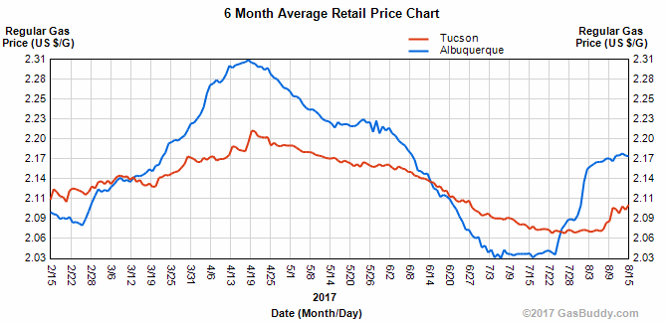

For which dates is the function $(T-A)(d)$…

…Positive?

… Negative?

… Zero?

What do each of these answers tell us about the price of gas in Tucson and Albuquerque?